
SRM Institute of Science and Technology Set D

College of Engineering and Technology

School of Computing

SRM Nagar, Kattankulathur – 603203, Chengalpattu District, Tamil Nadu

Academic Year: 2022-23 (Even)

Test: CLA-T1 Date: 13-02-2023

Course Code & Title: 18CSC204J Design and Analysis of AlgorithmsDuration:60 mins

Year & Sem: II Year / IV Sem Max. Marks:25

Course Articulation Matrix:
Course Outcome | PO1 | PO2 | PO3 | PO4 | PO5 | PO6 | PO7 | PO8 | PO9 | PO10 | PO11 | PO12
CO1 | 2 | 3 | - | - | - | - | - | - | - | - | - | -
CO2 | - | 3 | 2 | - | - | - | - | - | - | - | - | -
CO3 | - | 3 | 3 | - | - | - | - | - | - | - | - | -
CO4 | 3 | 2 | 3 | - | - | - | - | - | - | - | - | -
CO5 | 2 | 3 | - | - | - | - | - | - | - | - | - | -
CO6 | - | 2 | 3 | - | - | - | - | - | - | - | - | -

Part – A

(5 x 1 =5 Marks)

Instructions: Answer all
Q. No | Question | Marks | BL | CO | PO | PI Code
1 | ___ within the limit deals with the behavior of a function for sufficiently large values of its parameter.  a) Asymptotic notation  b) Big-Oh notation  c) Omega notation  d) Theta notation | 1 | 1 | 1 | 2 | 2.3.1
2 | A ___ is a compact, informal, and environment-independent description of a computer programming algorithm.  a) Stackb) Queue  c) Pseudocoded) Non-linear | 1 | 1 | 1 | 2 | 2.1.1
3 | How many number of passes are required for sorting 8 elements list in bubble sort in the worst case?  a) 0 b) 9c) 8d) 7 | 1 | 2 | 1 | 2 | 2.2.2
4 | The time factor when determining the efficiency ofalgorithm is measured by  a) Counting microseconds  b) Counting the number of key operations  c ) Counting the number of statements  d) Counting the kilobytes of algorithm | 1 | 2 | 1 | 2 | 2.1.2
5 | Which of the following recurrence relations can be used to find the nth fibonacci number?  a) f(n) = f(n) + f(n – 1)  b) f(n) = f(n) + f(n + 1)  c) f(n) = f(n – 1)  d) f(n) = f(n – 1) + f(n – 2) | 1 | 2 | 1 | 2 | 2.1.3

Part – B

(2 x 10 Marks = 20 Marks)

Instructions: Answer any 2 Questions
6 | Yash wants to buy to a phone to his mother. In the shop, the phones are in the unsorted list. He wants to check the phone features based on the price of the adjacent phone. Kindly help him to suggest the comparison-based algorithm which takes a more number of swapsto arrange it in order. The lists are, 50, 25, 5, 20,10. Also give the best and worst case of this scenario with time complexity.  Ans:  Bubble sort pseudocode (5):  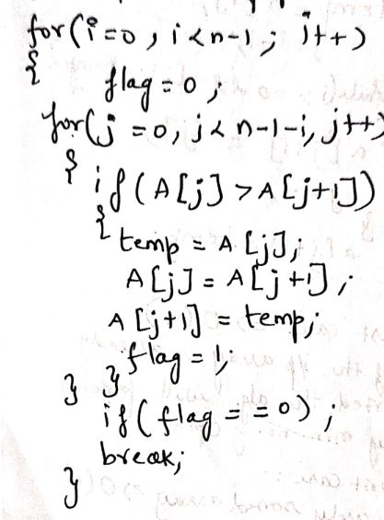  Dry run: (3)  Sorted: 5 10 20 25 50  Time Complexity Analysis: (2)  Best case- O(n)  Worst case - O(n^2) | 10 | 3 | 1 | 2 | 2.2.3
7 | Deduce the time complexity of a given relation using  Recursion Tree approach.  T(n) = T(n/4) + T(n/2) + n²; n>1  1 ; n=1  Ans:  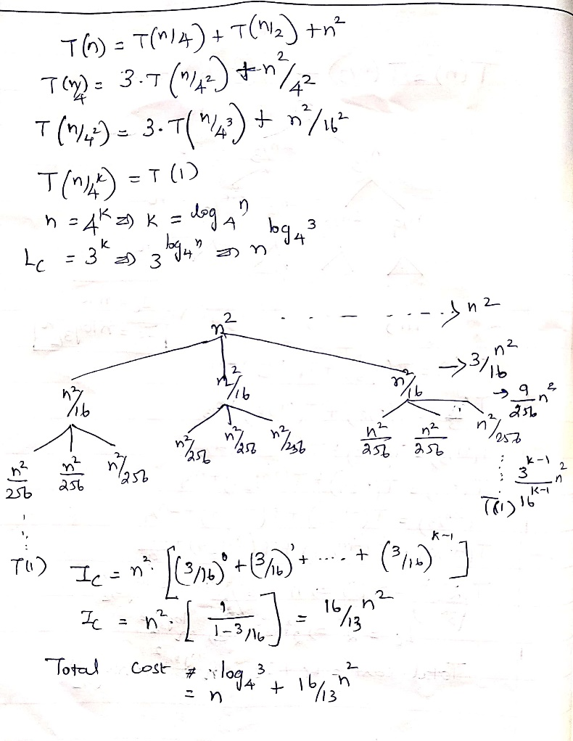 | 10 | 3 | 1 | 2 | 2.3.2
8 | (i) Given f(n)= 3n²+2n+5; g(n)=n². Show that f(n)=O(g(n)) and g(n)=θ(f(n)).  Ans:  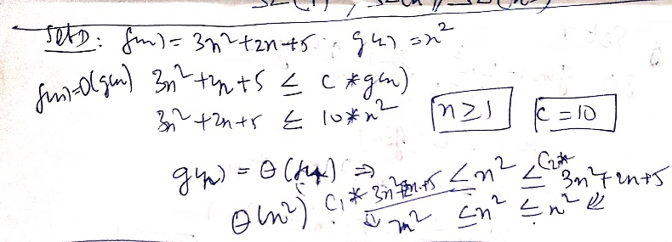  (ii) Consider problem P and provide various possible algorithm design techniques to solve the given problem.  Ans:  Briefing Divide and Conquer (1), Brach and Bound (1), Greedy (1), Dynamic Programming (1) and Backtracking (1) | 5  5 | 3  3 | 1  1 | 2  2 | 2.3.2  2.2.2

*Program Indicators are available separately for Computer Science and Engineering in AICTE examination reforms policy.

Course Outcome (CO) and Bloom’s level (BL) Coverage in Questions

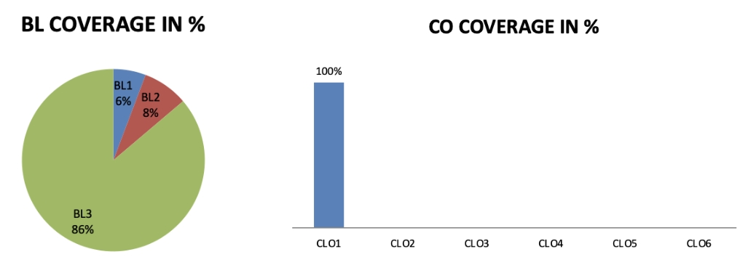

Approved by the Audit Professor/Course Coordinator

